

|  |  |  |  |  |  |  |
| --- | --- | --- | --- | --- | --- | --- |
| EXPRESS SERVICE STATION DOCUMENTATION  **Express Service Station**  Project Manager: Prof. Saad Razzaq  Project Team:   |  |  | | --- | --- | | Sajid Ali Khan **(Team leader)** | BCSF18E025 | | Shakeel Abbas Khan | BCSF18E030 | | Mohsin Farooq Khan | BCSF18E039 |   Submission Date:  17-January-2022  **_____________________**  Project Manager’s Signature |

**Table of Contents**

**1.** **Abstract 4**

**2.** **Background and Justification 4**

**3.** **Project Methodology 4**

**4.** **Project Scope 5**

**5.** **High-level Project Plan 5**

**SOFTWARE REQUIREMENT SPECIFICATION 6**

**6** **Introduction 12**

6.1 Purpose of Document 12

6.2 Project Overview 12

6.3 Scope 12

**7** **Overall System Description 12**

7.1 User Characteristics 12

**8 Operating Environment 12**

**9**  **System constraints 12**

**10** **External Interface Requirements 12**

10.1 Hardware Interfaces 12

10.2 Software Interfaces 12

**11** **Functional Requirements 12**

**12** **Non Functional Requirements 12**

12.1 Performance Requirements 12

12.2 Secuirity Requirements 12

**Software Design Specification**  12

**14** **Design Considerations 12**

14.1 Assumptions and Dependencies 12

14.2 Risks and Volatile Areas 12

**15** **System Architecture 13**

15.1 System-Level Architecture 13

15.2 Sub-System / Component / Module Level Architecture 13

**16** **Design Strategies 16**

18.1 Strategy 1…n 16

**17** **Detailed System Design 16**

*Relationships between classes 19*

**18** **References 41**

**19** **Appendices 41**

**Project Proposal**

# Abstract

*Mostly when people go to service stations to wash their vehicles, they have to wait a long time for their turn. We will resolve this issue by developing a Web based application, to save people's precious time, where users can book their time slots for washing their vehicles, and they arrive at their appointed time to get services regarding vehicles without wasting their time. Also our website provides different services like oil change, air filter replacement, fuel filter replacement, cabin filter replacement, wiper blades, headlights replacement etc.*

# Background and Justification

*We explored many websites and analyzed them. They contain many good features but somehow they also have drawbacks. The website limestone carwash [*[*1*](http://limestoneservicestation.com/appointments/)*] has many drawbacks including its home page is not user friendly and not attractive. Its home page does not contain images and detailed features about their work. They provide limited services and do not give any kind of packages. It has not given the payment method.*

*Another website which we have visited mrmahir car wash [*[*2*](https://mrmahir.com/car-wash-services)*]. It contains so many good features like they provide best services to the clients but also contain some weak points that do not contain any packages. This website does not provide any kind of payment method.*

*In our web based system we try to build all these feature which are lack in other websites۔We give the latest services of our work so people can judge our duties. We provide the packages to the client so they can choose the packages according to their needs. In other websites payment method is not available, if it has then a limited payment method is given. We try to make sure that we will give many payment methods like jazz cash, easy paisa and debit method etc. Our services include Express car wash, Express details, lube services (oil change, filter replacement, headlights etc.). We also provide a gallery in which images of our work services and ways to wash the vehicles.*

*Today life is busy and people have no leisure time to go to a service station and wash their vehicles. In this regard, we are trying to develop a portal where a person can register himself and book a slot for vehicle service. This will save their precious time.*

*Mostly when people go to service stations to wash their vehicles, they have to wait a long time for their turn. We will resolve this issue by developing a Web based application, to save people's precious time, where users can book their time slots for washing their vehicles, and they arrive at their appointed time to get services regarding vehicles without wasting their time.*

# Project Methodology

*In this project Our goal is to facilitate users regarding their vehicles. They can save their precious time by getting services on exact time. They can book their time slots according to their availability.*

*We will focus on usability of the application. User Interface will be user friendly. We will also focus on response time of the application. We will follow design guideline which are followed to make a generic website. We will try to control error response rate with proper validations.*

# Project Scope

*The scope of the Express Service Station is to develop a Web based application that performs smart and efficient functions to provide services to the user. Our website visited by those people who have vehicles and want to wash their vehicles. Those people who have no availability of android phone or internet connection can't get our services. A user will be able to book his slot though messages or call.*

*Our goal is to facilitate users regarding their vehicles. They can save their precious time by getting services on exact time. They can book their time slots according to their availability. Users can easily Register and book their appointments according to their availability in less time. Main Objectives are the system is a reliable secure and efficient, the system is available24/7, easy to use and friendly interface and this works with internet connectivity.*

# High-level Project Plan

*In this section we will create a good and user-friendly interface by using required tools and technologies should be mentioned to design and implement the project. We make a database of website where all the data of service station will be structurally stored. We will focus on usability of the application. User Interface will be user friendly. We will also focus on response time of the application. We will follow design guideline which are followed to make a generic website. We will try to control error response rate with proper validations.*

## List of Function Unit

* *Register*
* *Login*
* *Select city*
* *Select suitable Service Station*
* *Book his/her Time Slot*
* *Cancel his/her booking*
* *Logout*

## Gantt chart

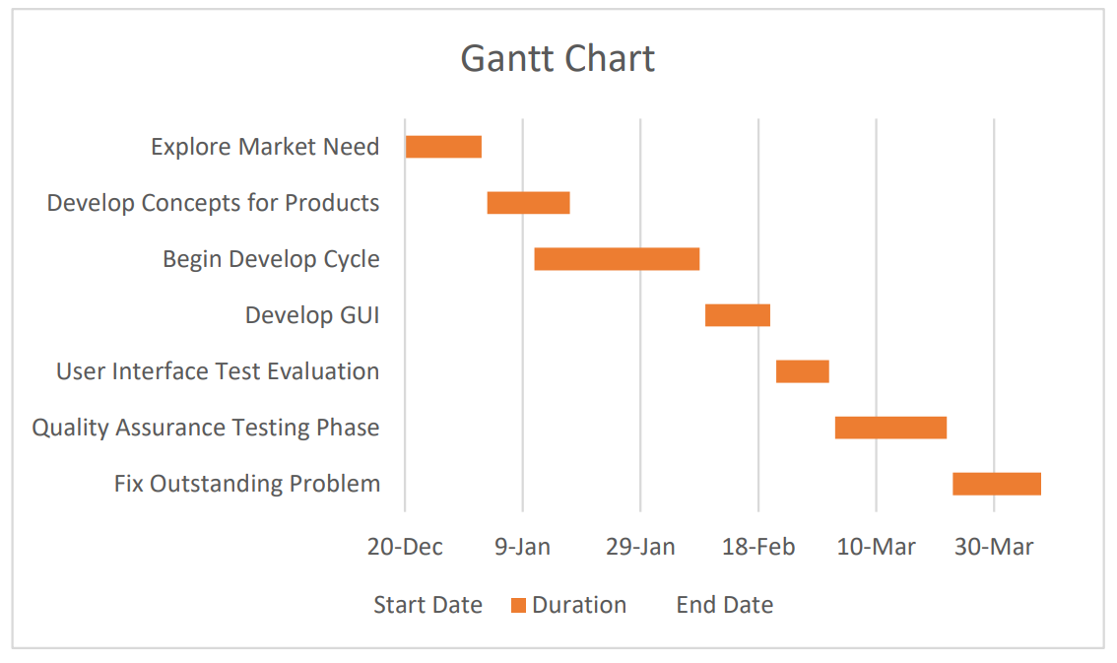

Figure 1- Gantt Chart

# SOFTWARE REQUIREMENT SPECIFICATION

1. **Introduction**

**6.1 Purpose of Document**

*Express Service Station allow users to book their time slots for washing their vehicles, and they arrive at their appointed time to get services regarding vehicles without wasting their time. Also portal provides different services like oil change, air filter replacement, fuel filter replacement, cabin filter replacement, wiper blades, headlights replacement etc.*

**6.2 Project Overview**

*This project is based on the web application development and provided the many of the functionalities to the users. They can save their precious time by getting services on exact time. They can book their time slots according to their availability. Users can easily Register and book their appointments according to their availability in less time. After registration in application, user would be qualified to contact the application owner, user require the internet connection whenever they sending request to the Admin and he will send the application to Head of Service Station.*

*Objectives:*

*1. Save time*

*2. Quick service*

*3. Easy to access*

*4. Better performance*

* 1. **Scope**

*The scope of the Express Service Station is to develop a Web based application that performs smart and efficient functions to provide services to the user. Our website visited by those people who have vehicles and want to wash their vehicles. Those people who have no availability of android phone or internet connection can't get our services. A user will be able to book his slot though messages or call.*

*Our goal is to facilitate users regarding their vehicles. They can save their precious time by getting services on exact time. They can book their time slots according to their availability. Users can easily Register and book their appointments according to their availability in less time. Main Objectives are the system is a reliable secure and efficient, the system is available24/7, easy to use and friendly interface and this works with internet connectivity.*

* *System will be able to provide online booking for washing vehicles.*
* *System will be able to provide suitable station where you can go easily.*
* *User will be able to cancel the booking in any emergency case.*
* *System will provide the rating and ranking of stations.*

1. **Overall System Description**

*Web application is based on Windows Operating System, so any devices, running this particular website Operating System will able to run website. This website can run on any browser because it is a web application.*

*For User Interface we use the languages HTML, CSS, Bootstrap JavaScript, JQuery. For Backend development we use the PHP language and for storing database we use XAMMP Server. We also used MS Visio for diagrams which are necessary for project*

* 1. **User characteristics**

*Express Service Station have two Admins, one is super Admin and another is sub Admin. The owner of the Web Application is Super Admin who controls all features of Website. Super Admin allows to see the features of Web Application to the Sub Admins. Sub Admins only work on those features which are allowed by Super Admin. They also have authority to control the user Interface and response to user.*

**User Roles:**

*They can view the general services as well as their specific packages.*

*They would be able to give feedback.*

*They will get notifications from the system.*

**Admin Roles:**

*They can view all the content (personal as well as general).*

*They simply enter the constraints i.e., (packages, services, users, payment method).*

*They can view feedback given by users and workout their queries.*

*They are authorized to manage the database and can edit the services and packages.*

*They are authorized to manage users booking slots.*

*They can edit the website.*

1. **Operating environment**

*The system will be able to operate on android devices. So, the user device must have the following specification for running the website smoothly. There should be no constraint on users being able to access the system at a given time. Web application is based on Windows Operating System, so any devices, running this particular website Operating System will able to run website. This website can run on any browser because it is a web application.*

**Admin requirements:**

*Device: Computer*

*Processor: Pentium (4),1.7MHz, Dual-core CPU or Higher*

*Hard Disk: 40GB*

*RAM: 8GB or Higher*

**User requirements:**

*Device: Android Device*

*ROM: Minimum 5 GB*

*RAM: 4 GB*

*Network Infrastructure to provide a connection to the application.*

1. **System constraints**

*Time scheduler requires some constraints that are given below:*

**Software constraints**

*The system requires the android studio 4.1 version or higher with API 16.*

**Hardware constraints**

*Smartphones, tablets, laptops with web browsers have good support for responsive websites.*

**Cultural constraints**

*The users of this application must be literate. All the users must be able to converse in English*

1. **External Interface Requirements**

*System cooperates with users through consistent and responsive UI through an application.*

* 1. **Hardware Interfaces**

*Smartphones, tablets, and computers with at least 2GB RAM having device version between android 4.1 up to android 10.*

* 1. **Software Interfaces**

1. **Functional Requirements**

*Functional requirements capture the intended behavior of the system. This behavior may be expressed as services, tasks or functions the system is required to perform.*

**Overview:**

*User can get basic over view of our services without signup or logging in.*

**User Registration:**

*User can register on website to place order and for getting information related to Express Service Station*

**User Login:**

*User can login to the portal and manage his/her dashboard*.

**Suitable Service Station:**

*User will be able to select service station that is suitable according to his/her location.*

**Book his/her Time Slot:**

*User can book available time slot through portal.*

**Cancel his/her booking:**

*User can cancel his/her booking after booking her slot and get his payment back after 20 percent deduction.*

**Payment:**

*User can pay through his/her bank account, easy paisa and jazz cash.*

**Discount Token:**

*Regular customer can get bonus discount using special tokens and our marketing offers.*

**Portfolio:**

*User can get information about our previous work and Projects.*

**Packages:**

*User can get different packages where we offer different services package in different prices.*

**Services:**

*Provides different services like oil change, air filter replacement, fuel filter replacement, cabin filter replacement, wiper blades, headlights replacement etc.*

**Location:**

*User can get location of Express Services Station*.

**Contact US:**

*User can contact us through Contact us form and through calls and SMS*.

**Subscription:**

*User can subscribe Express Service Station and can get latest information via emails.*

**SMS or Call:**

*User can also contact by SMS or call.*

1. **Non-functional Requirements**

**12.1 Performance Requirements**

*Login information shall be verified within five seconds.*

*Load time for the user interfaces no more than five seconds.*

*An application must respond to the feedback within less time.*

*Application will be maintainable. New modules can be added also can be change implemented.*

**Accuracy:**

*Admin and users view their correct services and packages that they receive from the system must be valid.*

**Reliability:**

*The system must be reliable; it enables the user to view their general services and if they want to give feedback and view their specific services, they require internet connection availability.*

**Maintainability:**

*The system must be flexible and maintainable developers can easily update the application in the future by adding new features to it.*

12.2 Security Requirements

*The system provides the security to the user. The data user enter will be secure and safe and can be access by authorized user. This system will not be harmful to the other PC data. Customer ID info secure in the database.*

**SOFTWARE DESIGN DOCUMENTATION**

**Document Information**

|  |  |
| --- | --- |
| **Category** | **Information** |
| University | UOS |
| Project | Express Service Station |
| Document | Design Document |
| Document Version | 1.0 |
| Identifier |  |
| Status | Draft |
| Author(s) | Sajid Ali Khan  Shakeel Abbas Khan  Mohsin Farooq Khan |
| Approver(s) | Sir Saad Razzaq |
| Issue Date | December 02, 2021 |
| Document Location |  |
| Distribution | 1. Advisor 2. PM 3. Project Office |

**Definition of Terms, Acronyms, and Abbreviations**

|  |  |
| --- | --- |
| **Term** | **Description** |
| UML | Unified modeling language |
| DFD | Data flow diagram |
| HCI | Human-computer interaction |
| GUI | Graphical user interface |
| ERD | Entity-relationship diagram |
| Db | Database |
| SRS | Software Requirement Specification |

# Introduction

**13.1 Purpose of Document**

*Express Service Station allow users to book their time slots for washing their vehicles, and they arrive at their appointed time to get services regarding vehicles without wasting their time. Also portal provides different services like oil change, air filter replacement, fuel filter replacement, cabin filter replacement, wiper blades, headlights replacement etc.*

1. **2 Project Overview**

*This project is based on the web application development and provided the many of the functionalities to the users. They can save their precious time by getting services on exact time. They can book their time slots according to their availability. Users can easily Register and book their appointments according to their availability in less time. After registration in application, user would be qualified to contact the application owner, user require the internet connection whenever they sending request to the Admin and he will send the application to Head of Service Station.*

*Provide a general description of the software system briefly stating its functionality and the basic design approach that you will undertake to develop the software*

# Design Considerations

*All possible design considerations are discussing in this section*

* 1. **Assumptions and Dependencies**

*Our system made multiple assumption and dependencies with users. Some of the assumptions are as follow:*

* *First of all, customer/branch owner must have an internet connection.*
* *Secondly, customer/ branch owner must have an android mobile or a system where he has an access of our application.*
* *Another assumption is, customer/ branch owner must have a version of 4 GB android or above.*
* *It is also assumed that our app is compatible with user’s hardware.*
* *Users must have enough space to install app in their system.*
  1. **Risks and Volatile Areas**

*The design structure of our system is very flexible. We can easily add a new module in the existing system. The risks which can occur in the system are following*

* *Fake account can cause of misguidance.*
* *Any software or hardware failure may occur.*
* *Any intruders in terms of hacker can affects our system.*
* *Database may crash.*
* *Server can be down.*

*With the passage of time, there is possibility that new requirements may arise regarding the application functionality or scope. Some of the volatile areas of the application are as follows:*

1. *The packages and services are being changed. New features are being added in vehicles and new technology is using day by day. So, there is a possibility that some more features may be available for upcoming days.*
2. *upgraded on a regular basis.*

**Future enhancement:**

*With the passage of time, there is possibility that new requirements may arise regarding the application functionality or scope. Some of the volatile areas of the application are as follows:*

*(i) The packages and services are being changed. New features are being added in vehicles and new technology is using day by day. So, there is a possibility that some more features may be available for upcoming days.*

*(i) upgraded on a regular basis.*

# System Architecture

*An architectural diagram is a diagram of a system that is used to abstract the overall outline of the software system and the relationships, constraints, and boundaries between components. It is an important tool as it provides an overall view of the physical deployment of the software system and its evolution roadmap.*

*To allow relevant users to understand a system architecture and follow it in their decision-making, we need to communicate information about the architecture. Architectural diagrams provide a great way to do this. To put down some major functions, an architectural diagram needs to:*

* *Break down communication barriers*
* *Reach a consensus*
* *Decrease ambiguity*

**Data Model**: Iterative Application Model It primarily focuses on preliminary growth and design and then gains momentum slowly with more complexity as well as meet requirements until the final software is built entirely. So, basically, the iterative development model is an approach of segmenting any large software development process into smaller portions. Since there is no detail planning, it makes it easier to incorporate the changes within the development process. An iterative life cycle model does not attempt to start with a full Specification of requirements. Instead, development begins by specifying and implementing just part of the software, which can then be reviewed in order to identify further requirements. This process is then repeated, producing a new version of the software for each cycle of the model. Consider an iterative life cycle model which consists of repeating the following four phases in sequence:

**Requirements phase**: in which the requirements for the software are gathered and analyst and Iteration should eventually result in a requirements phase that produces a complete and final specification of requirements.

**A Design phase**: in which a software solution to meet the requirements is designed. This may be a new design, or an extension of an earlier design.

**An Implementation and Test phase:** when the software is coded, integrated and tested.

**A Review phase:** in which the software is evaluated, the current requirements are reviewed, and changes and additions to requirements proposed.

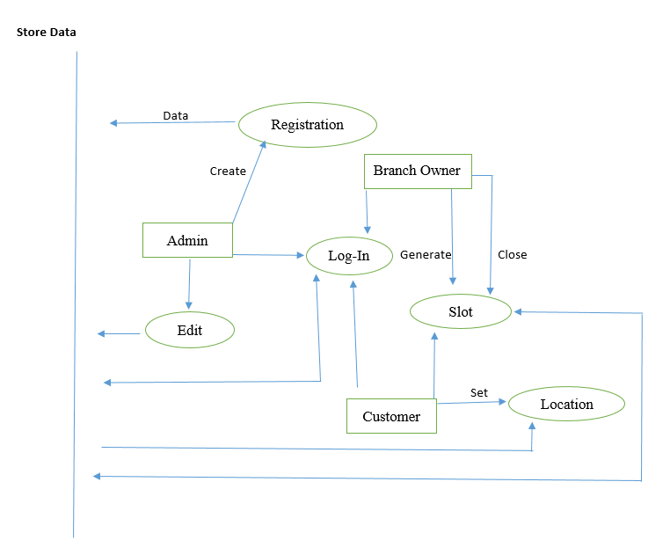

Figure 2.1-Data Flow Diagram

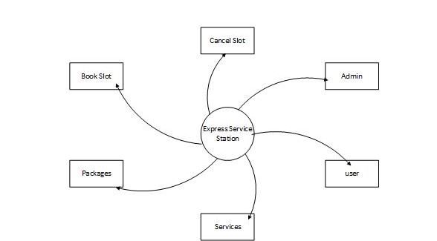

Figure 2.2-Data Flow Diagram

* 1. **System-Level Architecture**

*We are developing an application for the admin and customer which is helpful and time saving for customer and chance to avail the services online.*

*Our system divided into the following different modules.*

* *Admin*
* *Customer management*
* *Services management*
* *Service booking*

**Server**

**Database**

**Services**

**Customer**

**Branch Owner**

**Admin**

Figure 2.3-System-Level Architecture

* 1. **Sub-System / Component / Module Level Architecture**

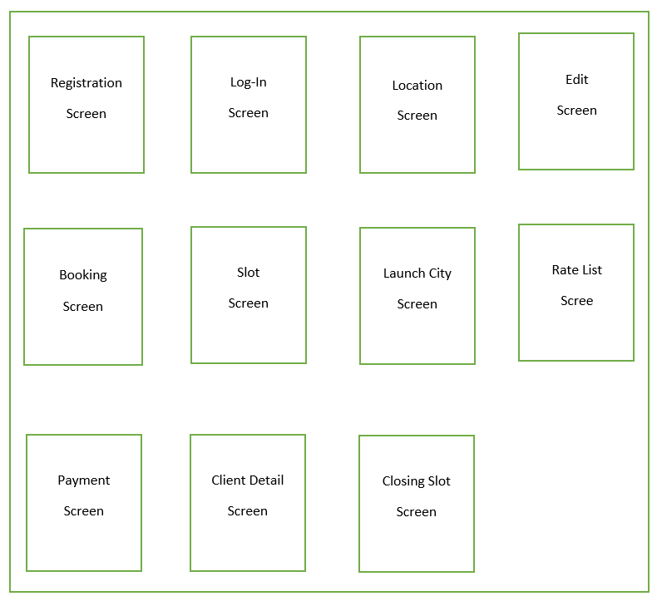

Figure 2.4-System Level Architecture

*.*

# Design Strategies

*The Express Service Station application will be developed by using the technique of divide and conquer. Basic idea is to partition the system into modules and sub-modules according to the functionality. This will help understand the dependencies within the system.*

**Future system extension or enhancement**

*We have a plan to add more functionalities in the future, to enhance the scope of our application. We will add functionality that the system will be able to provide information on services like it provides future changing services and payment changes due to changes up and down of monetary and many other issues.*

**16.1 Structure design strategy**

*It gives us the concept of different modules in a proper defined solution. This strategy will help us to be more focused on our issues. It works exactly like the word and conquer. This strategy makes it easier for us to give the accurate and precise solution module and build them up as a complete project.*

**16.2 Future enhancement:**

*There is a possibility of enhancement in application's scope as new modification and technologies trends in vehicles are being changed. New details may be added with the passage of time.*

**16.3 User interface paradigm:**

*System well build is UI on web depending on the role of GUI. UI must be user-friendly, effective and easy to acknowledge.*

**16.4 Reusability:**

*The Express Service Station application will be designed following the principles of portability and interoperability. Its modules can be reused in other applications.*

# Detailed System Design

*Use Case Diagram*

*Use cases are written for understanding the Express Service Station application’s behavior from the user point of view. Each use case describes a different scenario and application response.*

*The user case diagram here explains the working environment of the Express Service Station application. That is how the user interacts with the system and how the modules such as “Services”, “Packages”, “login & logout” and “Database” are interconnected.*

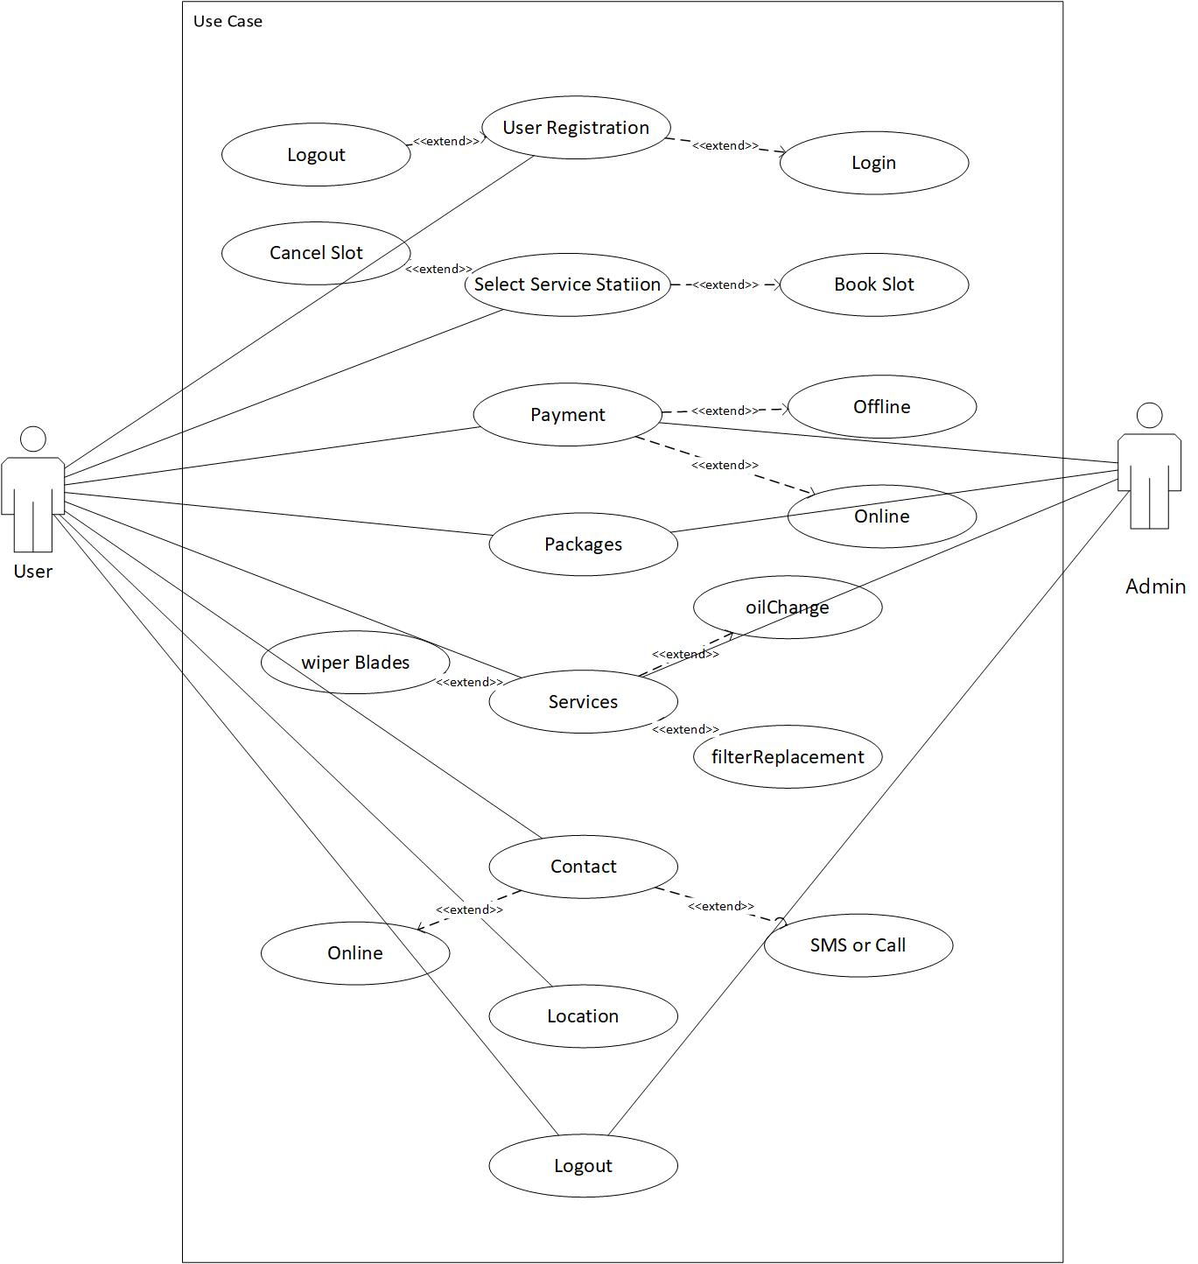

Figure 3- Use Case Diagram

*Use Case Description*

*Each Use Case has a description, which describes the functionality that will be built in the proposed system. The template for Use Case description is given below:*

* **Use Cases:**

|  |  |
| --- | --- |
| **User Registration** | |
| **Use Case No:** | **1** |
| **Use Case Name:** | *User, Admin* |
| **Description:** | *Create an account use case that allows admin, and customer to create their accounts and become a registered member.* |
| **Preconditions:** | *User should be on home screen of the web application.* |
| **Inputs:** | * *Admin enters the id, name, email, and password.* * *User enter Name, id, email, and password.* |
| **Main Course:** | * *The system will ask to choose a strong password.* * *The system will ask to re-enter the password.* * *The account will be created after clicking on the signup button.* |
| **Outputs:** | *customers, and admin are now registered.* |
| **Post conditions**: | *Actors successfully register and view the services.* |

|  |  |
| --- | --- |
| **Select Service Station** | |
| **Use Case No:** | **2** |
| **Use Case Name:** | *User, Admin* |
| **Description:** | *It’s all depend on the user that he or she select the nearer or suitable service station through the website.* |
| **Preconditions:** | *The device in which the application resides, has an active internet connection. The user is confident that he/ she is selecting the right service.* |
| **Inputs:** | * *Admin will be able to give all details about service station location.* * *User then select suitable service station.* |
| **Main Course:** | * *Admin will be able to give all details about service station location.* * *User then select suitable service station.* |
| **Outputs:** | *User will select suitable service station.* |
| **Post conditions**: | *User will select suitable service station.* |

|  |  |
| --- | --- |
| **Payment** | |
| **Use Case No:** | **3** |
| **Use Case Name:** | *User, Admin* |
| **Description:** | *Create an account use case that allows admin, and customer to create their accounts and become a registered member.* |
| **Preconditions:** | *User will be able to select suitable payment method like Jazz cash or easy paisa and through bank account.* |
| **Inputs:** | * *Admin allows the user to select suitable method like Jazz cash or easy paisa and through bank account.* * *User is able to pay money through these methods.* |
| **Main Course:** | * *If the user has not a bank account then it depends on user to pay through other different methods or pay through by hand.* |
| **Outputs:** | *Actors will manage payment method successfully* |
| **Post conditions**: | *Actors will manage payment method successfully.* |

|  |  |
| --- | --- |
| **Packages** | |
| **Use Case No:** | **4** |
| **Use Case Name:** | *User, Admin* |
| **Description:** | *Different packages are given by the admin and then user is able to select them according to his/her condition.* |
| **Preconditions:** | *User is able to select different packages according to condition of the services.* |
| **Inputs:** | * *Admin allows different packages to user.* * *User is able to select different packages according to condition of the services.* |
| **Main Course:** | * *It’s all depend on the user which package he/she wants to select.* |
| **Outputs:** | *Actors will manage packages successfully* |
| **Post conditions**: | *Actors will manage packages successfully* |

|  |  |
| --- | --- |
| **Services** | |
| **Use Case No:** | **5** |
| **Use Case Name:** | *User, Admin* |
| **Description:** | *Different services are given by the admin and then user is able to select them according to his/her condition.* |
| **Preconditions:** | *User is able to select different services according to condition of the vehicle.* |
| **Inputs:** | * *Admin allows different services to user.* * *User is able to select different services according to condition of the vehicle.* |
| **Main Course:** | * *It’s all depend on the user which services he/she wants to select.* |
| **Outputs:** | *Actors will manage services successfully* |
| **Post conditions**: | *Actors will manage services successfully* |

|  |  |
| --- | --- |
| **Location** | |
| **Use Case No:** | **6** |
| **Use Case Name:** | *User, Admin* |
| **Description:** | *This use case allows teachers and students to get notifications of the coming to class.* |
| **Preconditions:** | *User should be on home screen of the web application.* |
| **Inputs:** | * *Admin is responsible for giving the location of service station.* * *User get the location through maps.* |
| **Main Course:** | * *User get the location of the service station through maps.* |
| **Outputs:** | *user will able to selects suitable service station successfully.* |
| **Post conditions**: | *user will able to selects suitable service station successfully.* |

|  |  |
| --- | --- |
| **Contact** | |
| **Use Case No:** | **7** |
| **Use Case Name:** | *User, Admin* |
| **Description:** | *User should be able to contact the admin through contact form.* |
| **Preconditions:** | *User should be on home screen of the web application.* |
| **Inputs:** | * *Admin enters the id, name, email, and password.* * *User enter Name, id, email, and password.* |
| **Main Course:** | * *The system will ask to choose a strong password.* * *The system will ask to re-enter the password.* * *The account will be created after clicking on the signup button.* |
| **Outputs:** | *user will able to contact with admin successfully.* |
| **Post conditions**: | *user will able to contact with admin successfully.* |

|  |  |
| --- | --- |
| **Logout** | |
| **Use Case No:** | **8** |
| **Use Case Name:** | *User, Admin* |
| **Description:** | *This use case allows to logout to the account.* |
| **Preconditions:** | *To logout users and admin created an account* |
| **Inputs:** | * *Admin enter email and password.* * *User enter email and password* |
| **Main Course:** | * *The admin and user can logout from the website.* |
| **Outputs:** | *The users, and admin are now logged out.* |
| **Post conditions**: | *Actors successfully log out and view the login page.* |

**Class Diagram:**

*Class diagram in the Unified Modeling Language (UML) is a type of static structure diagram that describes the structure of a system by showing the system's classes, their attributes, operations and the relationships among objects*

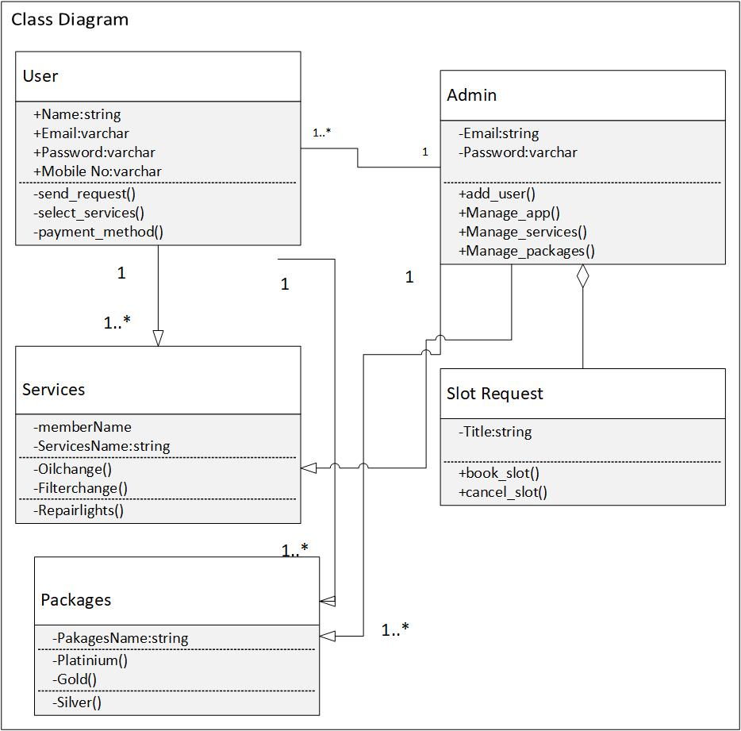

Figure 4- Class Diagram

**Class Name:**

*The name of the class appears in the first partition.*

**Class Attributes:**

*Attributes are shown in the second partition.*

*The attribute type is shown after the colon.*

*Attributes map onto member variables (data members) in code.*

**Class Operations (Methods):**

*Operations are shown in the third partition.*

*The service the class provides.*

*Operations map onto class methods in code*

*Few details about the classes and their attributes and their functions.*

***User Class:***

*The user class represents the actions that can be performed by the Express Service Station application’s user such as exploring the services information, initiating the packages process and getting notified about the selecting the services, login and logout schedules.*

**Attribute:**

*User Name*

*User Email*

*User Password*

*User Mobile No*

**Function:**

* ***Send Request***

*//this information covers send request which user can send it to the admin.*

* ***Select Services***

*// User can select any services according to the packages which are given on the website.*

* ***Payment method***

*// includes information about the payment which is given by the user.*

***Admin Class:***

*Admin is an abstract class and will deal with the emerging needs of the application’s users by adding and updating the Service Station information.*

**Attribute**

* *Admin Email*
* *Admin Password*

**Function.**

* ***Add User***

*// admin will be able to add the user and also navigates the user which he would not to add.*

* ***Manage app***

*// Admin is responsible for adding, updating and deleting (if necessary) the information about //any Service Station.*

* ***Manage Services***

*// Admin is responsible for dealing with the user’s selecting services and updating or modifying the information accordingly.*

* ***Manage Packages***

*// Admin is responsible for dealing with the user’s selecting services and according to selection manages packages and updating or modifying the information accordingly.*

***Services Class:***

*The services class is used to show a list of services and also show detailed information of services that will be retrieved from the database.*

**Attribute**

* *Member Name*
* *Services Name*

**Function.**

* ***Oil Change***
* ***Lube Services***
* ***Wash Club***
* ***Wiper Blades***
* ***Headlights Replacements***
* ***Filter Change***
* ***Repair lights***

***Slot Request Class:***

*The slot request class is used to show a list of slots and also show detailed information of slots that will be book or cancel by user or admin.*

**Attribute**

* *Title*

**Function.**

* ***Book Slot***
* ***Cancel Slot***

***Packages Class:***

*The packages class is used to show a list of packages and also show detailed information of packages that will be retrieved from the database.*

**Attribute**

* *Package Name*

**Function.**

* ***Platinum***
* ***Gold***
* ***Silver***

**Sequence Diagram:**

*Sequence diagrams, commonly used by developers, model the interactions between objects in a single use case. They illustrate how the different parts of a system interact with each other to carry out a function, and the order in which the interactions occur when a particular use case is executed.*

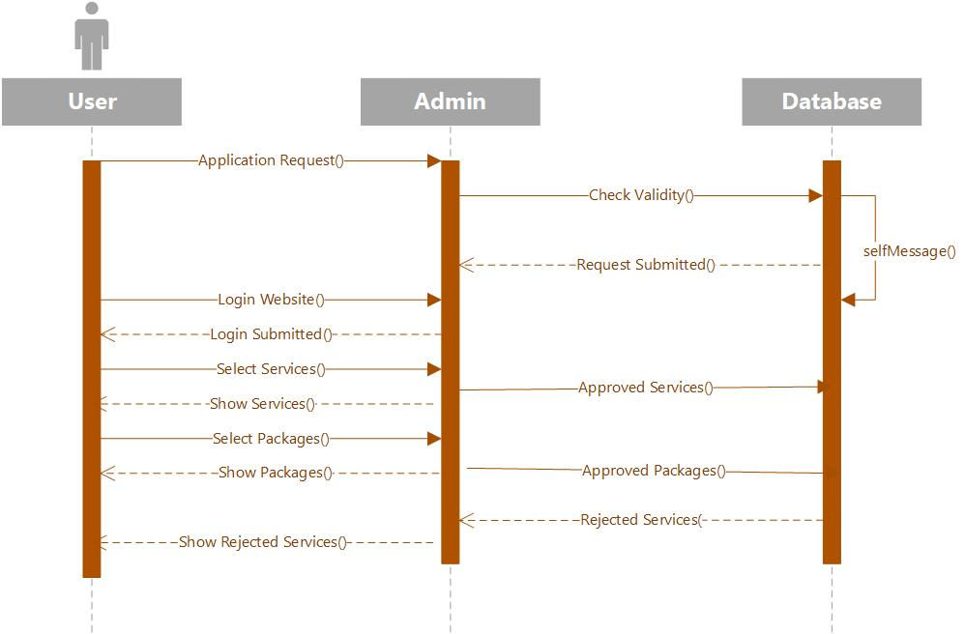

Figure 5.1- Sequence Diagram

For Admin

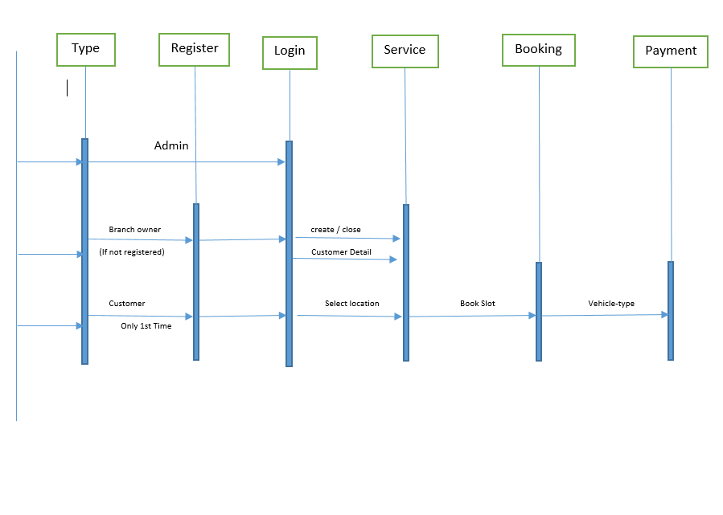

Figure 5.2- Sequence Diagram

**State Diagram:**

*State-Machine diagram is used to model interactive systems and elaborate all the possible states of any object or module in the system. It depicts the dynamic behavior of the system. So, this diagram is to describe the Express Service Station application’s point of interactions from the user point of view. All the states which may occur within the system are explained below.*

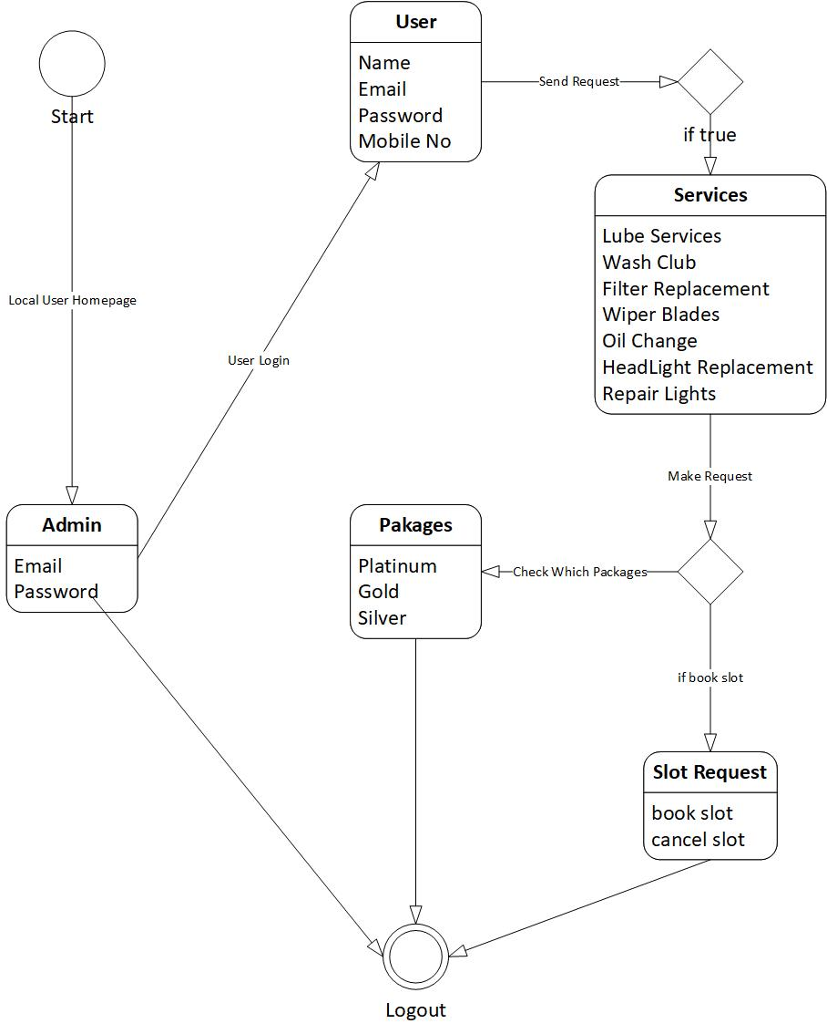

Figure 6- State Diagram

**Entity Relationship Diagram:**

*ER model represent the relationship of entities with system intended objects and their behavior upon specific tasks.*

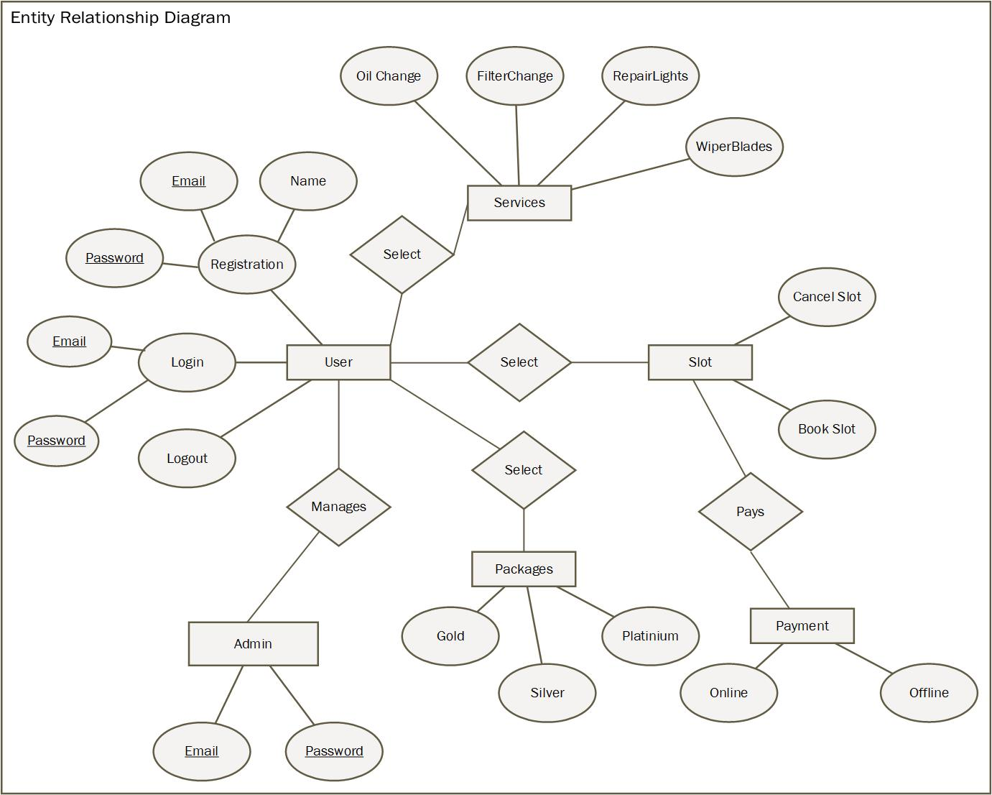

Figure 7- Entity Relationship Diagram

* ***Detailed Graphical User Interface:***

|  |
| --- |
| **Registration form** |
| **Snapshot:** |

|  |
| --- |
| **LOGIN FORM** |
| **Snapshot:** |

|  |
| --- |
| **Dashboard** |
| **Snapshot:** |

|  |
| --- |
| **Location** |
| **Snapshot:** |

|  |
| --- |
| **Services** |
| **Snapshot:** |

|  |
| --- |
| **Contact US** |
| **Snapshot:** |

# 

# References

|  |  |  |  |
| --- | --- | --- | --- |
| **Ref. No.** | **Document Title** | **Date of Release/ Publication** | **Document Source** |
| Express Service Station-2021-Proposal | Project Proposal | December-01-2021 | <http://limestoneservicestation.com/appointments/> |
| Express Service Station -2021-Software Requirement Specification | Software Requirement Specification | December-21-2021 | <https://mrmahir.com/car-wash-services> |
|  |  |  |  |

# 

# Appendices

**Three-tier architecture:**

*A three-tier architecture is a client-server architecture in which the functional process logic, data access, computer data storage, and user interface are developed and maintained as independent modules on separate platforms*

**Unified Modeling Language:**

***UML****, short for Unified Modeling Language, is a standardized modeling language consisting of an integrated set of diagrams, developed to help system and software developers for specifying, visualizing, constructing, and documenting the artifacts of software systems, as well as for business modeling*